UQ Sustainability Week –

SMI Photo Competition 2018
Contact details of entrant
First Name
Surname
Email address
Contact number
Photo 1
Image reference
Where was the image taken?
When was the image taken?
Caption (max 200 words)
Additional information (optional)
Photo 2 (optional)
Image reference
Where was the image taken?
When was the image taken?
Caption (max 200 words)
Additional information (optional)
I confirm I am :
• 18 years old or older on the competition opening day (2 July 2018)
• I agree to the Terms & Conditions set out in the following pages
Signature
Date
Submit image/s and entry form by 5pm on Thursday 9 August 2018 to smi@uq.edu.au

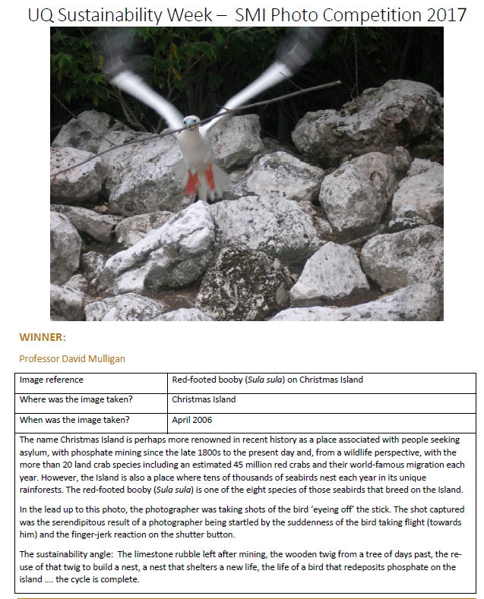

UQ Sustainability Week –

SMI Photo Competition 2018

Competition dates
Entries open at 9am on 2 July 2018
Entries close 5pm on Thursday 9 August 2018
SMI Photo Competition Winner/s will be announced at 11am on Thursday 23 August 2018. The winner/s will be contacted that day and a notice will be printed in SMI This Week (local newsletter). Where possible, a notice will also be posted to SMI’s Facebook, Twitter and LinkedIn pages.
Prizes
The winning image/s will be printed, mounted and displayed throughout the Sustainable Minerals Institute with acknowledgment to the photographer.

Overview
SMI are encouraging contributions from current staff, students and alumni of images depicting responsible resource development.
Inspirational and artistic interpretations of responsible resource development from around the world are most welcome!
Images submitted will be added to SMI’s image library for use by staff and researchers in reports and other publications as well as on SMI’s website and social media. Images will be credited where possible. By submitting an image into this competition you are agreeing to the terms and conditions set out below.

WHO CAN ENTER?
Submissions are welcome from UQ staff, students and alumni – this competition is not limited to just Sustainable Minerals Institute staff, students and alumni.
To be eligible applicants MUST:
- Be 18 years old or older on the competition opening day (2 July 2018)
- Submit a high resolution photograph in digital format which meets the criteria set out in the Guidelines/How to Enter sections
- Agree to the Terms & Conditions

HOW TO ENTER
Submit a maximum of two images (JPEG format, no larger than 10MB each, minimum pixel size: 2500 x 3750).
Each entry must include a completed entry form and include a description in 200 words (or fewer) of where and when the image was taken.
Submissions should be emailed to smi@uq.edu.au

GUIDELINES
Entries open at 9am on 2 July 2018; Entries close 5pm on Thursday 9 August 2018
SMI Photo Competition Winners will be announced at 11am on Thursday 23 August 2018
There are no fees associated with entering the competition
Each entrant may submit a maximum of two photos in JPEG format. Mobile photo entries will be accepted if they meet the size requirement. Video and print images are not able to be accepted
Maximum file size: 10 MB (per photo); Minimum size: 2500 x 3750 pixels
Photo submissions must be the entrants own work and unpublished
All entrants must complete an entry form
Captions are critical. Each photo must be accompanied by a short descriptive caption (maximum 200 characters). Well-written captions are needed so judges can understand the context of the image.

JUDGING:
The judging panel will consist of:
- Professor Neville Plint –UQ Sustainable Minerals Institute Director
- Melissa Glendenning – UQ Sustainable Minerals Institute Deputy Director - Operations
- Tyne Hamilton – UQ Sustainable Minerals Institute Digital Marketing Officer

TERMS & CONDITIONS
Entry into the competition is deemed acceptance of the following terms and conditions:
- The information above outlining the competition forms part of the terms and conditions.
- All entries to the competition must be the photo (i.e. the “work”) of the entrant and must not have been awarded a prize in any other photographic competition.
- The entry warrants that they hold all necessary copyright title and interest in their entry to entitle them to enter the competition and to provide UQ with the rights provided for in these conditions. The intellectual property rights, including copyright rights, to the work will remain with the photographer. The entrant will be credited wherever possible. By entering the competition, the entrant grants a worldwide, irrevocable, perpetual, non-commercial, non-exclusive royalty-free license to the Sustainable Minerals Institute (“the Institute”) and The University of Queensland (“UQ”). This license includes (but is not limited to) the right to use, publish, reproduce and feature any or all aspects of the work in any of the documentation, media work and/or promotion of events by the Sustainable Minerals Institute (“SMI”).
- It is the responsibility of each entrant to ensure that any images they submit have been taken with the consent of the subject and do not infringe their rights, including privacy rights, intellectual property rights, including copyright or any other rights of any person. The entrant warrants that all persons who are identified in the photograph are aware that the photograph is to be entered in this competition and that they have consented to the use by SMI and UQ for any purposes that fall within the scope of the copyright licence granted under these terms and conditions. By entering this competition, all entrants agree to hold Sustainable Minerals Institute, The University of Queensland and the judging panel free and harmless of any claims, costs or expenses, including but not limited to damages, arising out of the participation in this competition or any competition-related activities and the acceptance and use, misuse or possession of any prize awarded here under. To the extent permitted by law, UQ excludes any and all liability to the entrant for any loss, damage or expense suffered by the entrant that arises out of, or relates to, the competition.
- The Sustainable Minerals Institute reserves the right not to award a winner if none of the submissions meets the quality requirements.
- Entry is open to current UQ staff, students, and alumni, including staff working directly for the UQ Sustainable Minerals Institute.
- Images should be captured from ‘real life’ and not computer-generated.
- SMI reserves the right to use any images entered in the competition in its promotional material. Where images are used in such material every effort will be made to acknowledge the photographer in a manner considered appropriate by the Institute. Entrants to their name being published by SMI and UQ for promotion purposes.
- SMI reserves the right to verify the validity of entries and to disqualify any entry which, in the opinion of the Institute includes objectionable content, profanity, potentially insulting, inflammatory or defamatory statements, disqualify any entrant who tampers with the entry process, who submits an entry that is not in accordance with these Terms and Conditions or who has, in the opinion of SMI, engaged in conduct in entering the promotion which is fraudulent, misleading, deceptive or generally damaging to the goodwill or reputation of the University. The Institute reserves the right to disqualify a winner if it becomes aware that the winner and/or the winner's entry is of a type described in this clause.
- SMI accepts no responsibility for any late, lost or misdirected entries not received by the SMI or delays in the delivery due to technical disruptions, network congestion or for any other reason.
- 11. This competition is governed by the laws of Queensland, Australia.

